 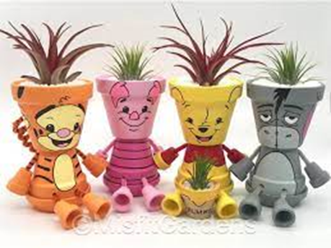

**ENTRY FORM BUDDIES POT CHARACTER**

Thank you for completing and returning to Gold Coast Show office to register your entry(s) in

Buddies – Green Gardening Pot Character Competition.

Each Childcare Centre can enter more than one item based on the age of each green group

**Entries close Wednesday 18th August 2021:** email to [com@goldcoastshow.com.au](mailto:com@goldcoastshow.com.au)

The items themselves are not required until the delivery date **Thursday 26th August between 2-4pm**.

**Delivery address** is at *Gold Coast Show Farmland Precinct,* **Broadwater Parklands Southport**

Enter from the Gold Coast Highway at the Aquatic Centre entrance but then turn sharp left (facing north) do not go past the Aquatic Centre.

**Collection** of the items is between 3-5pm Sunday **29th August**

Winners and runner ups will be announced Friday and identified at the Farmland display area.

*May you all enjoy going creatively potty* - 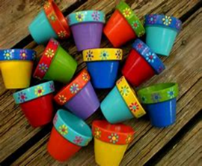

**Yes, Our Centre wish to participate in Garden Pot Character Show Activity**

**No of Items: ……………………………………………..** Age of each creative team: ……………………………………

Contact Name: ………………………………………….. Title ………………………………………………………………………

Childcare centre name: ………………………………………………………………………………………………………………….

Address: …………………………………………………………………………………………………………………………………………

Phone ………………………………………………………….Email……………………………………………………………………….

Gold Coast Show Society ***See you at the Show***

Phone: 07 55 045587 /0474304017 www.goldcoastshow.com.au